REPORT OF THE RURAL MOUNTAIN
HOTEL “POSADA DE LOS ARRIEROS”

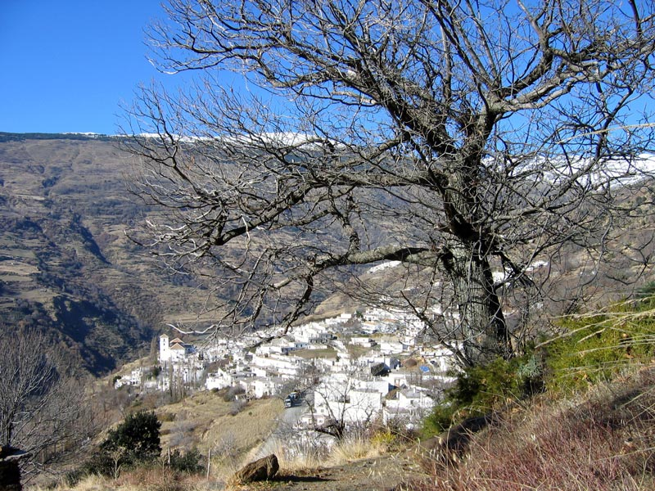

1-GEOGRAPHIC SITUATION:
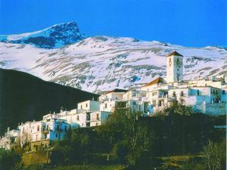

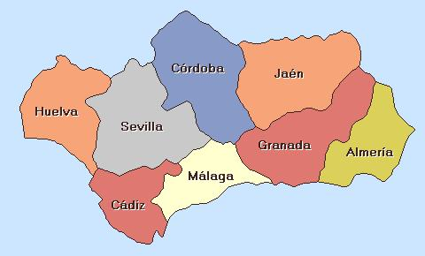


Located in the municipal area of the village Bayárcal, in the Province of Almeria, to be exact in the place called “Puerto de la Raga”, in the National Park of Sierra Nevada. Region called “ALPUJARRA” highly charged of history, especially during the Muslim ARABIC domination (IX to XV century)

2-DISTANCES:
- 5 KMS. From the Winter Sports Station of the “Puerto de la Ragua”, floor Nordic ski, between the provinces of Almería and Granada, with a very good access over a regional road.
- 100 KMS. To Almería – 75kms. To El Ejido, 60kms. to Adra
- 96 KMS to Granada
- 34 kms. To Guadix-
- 15 kms. To La Calahorra, with its famous castle from 14th century-
- 125kms. to the Ski resort Station of Sierra Nevada.

- 3- CHARACTERISTICS OF THE REGION:

The Winter Sports Station “Puerto de la Ragua” is located on the east face of the Penibetico Massif of Sierra Nevada, and since 1999, officially declared as National Park. ACcordingly to this, the area meets the best conditions for the practice of Winter Sports (especially Nordic ski), as well as adventure sports in the environment, such as:

- Horseback tours among astonishing panoramic views over the pine-wood and the meseta of El Zenete.
- Trekking
- Hiking
- Nordic Ski
- Climbing
- Walking on snow rackets
- Nordic Ski, hiking,
- Archery, scalade
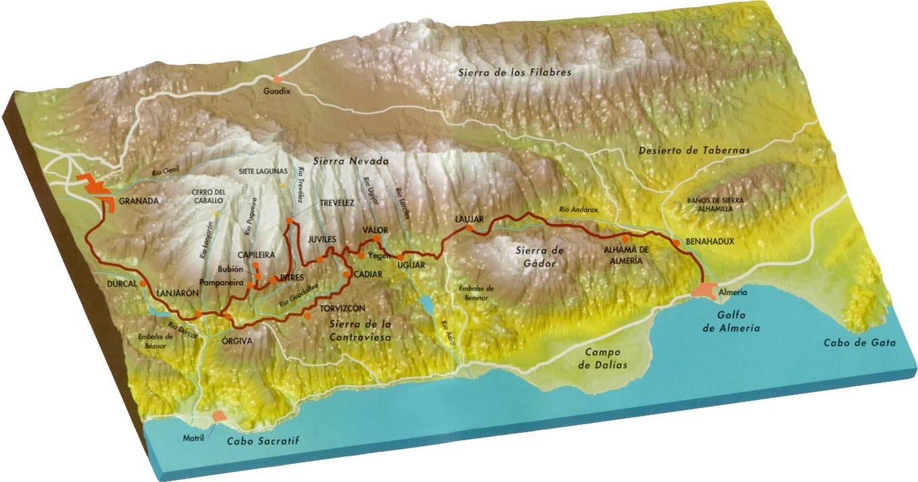
- Ecological hunt

OUR HOTEL:

- Located at an altitude of 1.740 meters over sea level, completely isolated in the environment and surrounded by a nice and huge pine forest, in the heart of the Sierra Nevada National Park. Through our nice finca of 22 Hectares, flews a streams small mountain river, which provides us generously with plenty of water for spreading and watering for the whole urbanisation.

We can presume also of a total exclusive accommodation in the area, for the Spanish Laws for National Parks are very strict on this matter. (No more constructions in the protected area).

- The building is erected upon the foundations of an old and legendary Inn from the 19th Century called “Venta del Zamburino”, further called “Venta del Barranco”. This was a refuge and shelter for all the “Arrieros” ( merchants on mule), who were crossing the Puerto de la Ragua, to bring food , and fishes from the Coasts and beaches of Almería to inside land of the province of Granada.
- Also to mention the very famous track called GR-7, an old famous Roman route between Athens and Gibraltar, who passes beside our Hotel.

CAPACIty:
basement FLOOR: 9 DOUBLE rooms + extra bed

1 APARTAMENT management
NEW PAVILLION : 9 DOUBLE rooms+ extra bed
1 SUITE SENIOR
1 SUITE JUNIOR

GROUND FLOOR 2 doublerooms + extra bed

LODGES (HERBERG): 6 MULTIPLE ROOMS (capacity 50 pax)

exterior: 2 WOODEN BUNGALOWS

total uniTS : 31 UNITS

SCHEDULE FOR SURFACES AND DISTRIBUTION

SURFACES:

- PLOT OF LAND
- Land: Total Registered ……………………….……..….56.560,00 m2
- Total according to Cataster:……………...……….… 220,000,00 m2

- TRADITIONAL BUILDING:
- Floor principal level……………………………..………. 1.099,30m2

- Ground floor……………………………………………..…..380,00 m2

- First floor……………………………………………..………540,00 m2

- SECOND PAVILLION:
- Ground floor…………………………………..……………..474,60m2

- First floor ………………………………………….………...256,10 m2

- Multipurpose hall……………………………….……...…. 91,80 m2

- 2 wooden Houses …………………………………….…... 71,70 m2

- New storage room………………………..…………..….… 41,40 m2

- Apartment Management……………………………………80,00 m2

- Laundry …………………………………………….….……. 25,00 m2

- Black water depurator…………………………………….. 14,50 m2

- Extra construction water tanks………….…….…………12,80 m2

Total constructions ………………………..……….2.514,20 m2

The entire hotel's decoration has been realized very exclusively, faithfully and strictly according to the tradition of building in this region ALPUJARRA, using materials in their nature range, primarily stone from the area, launa (ceilings coverage) chestnut beams and sticks, making sure their structures with stability and respecting the environment and habitat of the rural area to which we belong.

Here are the fundamental structures:

- GROUND FLOOR:

- Description and distribution:

- Lobby and Reception

- Large lounge and reading AREA, WITH T.V and chimney.

- - 2 double rooms with private bathrooms.

- 6 large Lodges accommodation, with a minimum of 6 and maximum 12 people and up to 25 people on lodging for groups. groups of up to 50 people, all with central heating, and making TV)

- 1 large lounge room with TV and central heating

- This plant enjoys collective services and bathrooms for both sexes, with services and prepared special facility for the disabled. In this plant, we have an assistant 40.-flag m2 for staff accommodation with two bedrooms and bathroom –

MAIN FLOOR: (traditional Pavilion)

- With direct access from the Reception or from the entry level to the Restaurant –

- Kitchen completely equipped with Pantry

- Bar-Cafeteria

- Restaurant-Dining room with capacity for 150 people specialized in typical dishes from the Region Alpujarra (roasted lamb, grilled meats, soups, home-made sweets, etc.)

- -9 Double Rooms very spacious, recently refurbished, converted into triples and even quadruples, all with bath and outdoor complete individual and central heating.

- - Apartment OF direction, with an area of 110.00 m2 terrace interiors, fully lined with wood heating and comprising hall, 2 bedrooms with fitted wardrobes, lounge

MAIN FLOOR-new Pavilion

DISTRIBUTION: Built in 2 levels:

Main Floor:

  - Living room with fireplace, tastefully decorated, with access to the old as well as an outdoor patio Arabic.

  - 6 double rooms, all exterior and with central heating, very large, convertible into four, and typically decorated ALPUJARREÑOS rate.

  - 1 Suite "La Roca" of 60.-m2 with a bathroom built into the rock of the mountain, and heated by radiant floor mud. <
  - First Floor-Ala new

FIRST Floor:
  - 3 double rooms, all exterior, with private bathroom and central heating, decorated with typically ALPUJARREÑOS atmosphere and very spacious.

  - 1 Suite”Panoramica" wide, radiant heating and terrace, and a wonderful view over the valley and mountains.

  - -The building has also:

Summer Terrace with panoramic views to the park

  - Central Heating in all rooms and common areas

  - Natural fireplace on each floor

OTHER EXTERIOR STRUCTURES:

- Multipurpose Hall Salon , with facilities for audio and megaphone, projection screen and Canon video / DVD, with capacity for 50 people

- - Fitness equipment

- - 2 wooden houses completely furnished and distributed with entry, living room, 1 bathroom and a bedroom with water, electricity, central heating and TV.
- Private indoor parking area.
- EQUESTRIAN FACILITIES: -EQUESTRIAN CLUB

- Built surface area: 427.60 m2. , distributed as here-below:

- - 18 large boxes for horses fully equipped

- - large storage room –reception with fireplace

- - Rick and barn

- - House and several rooms for animals

- - Fully fenced Track 17 mts. x 35 meters

- - Fully Fenced Track 15mts x 20mts

- - 3 fenced plots with water for brood mares

- -For the development of the hotel business, are available from the following structures:

- - Use of natural spring water through the storage tanks with capacity of 4000 litters, with sodium hypochlorite dosing for sanitary fittings. - Wastewater Treatment: The wastewater generated is treated in the plant installed for that purpose in the South of our property

OTHER FACILITIES

.
- Electrical system: it generates autonomously through three generators, diesel and gas, respectively, supplemented by a solar power installation with two investors, 5000 W and 3000W respectively

- -Solar panels- occasionally out of service (one of the most important in this area with 48 units), being supplied with our clean and inexpensive energy.

- 1 diesel generator of 55 KW power

- 1 diesel generator of 88 Kw. power

- Propane Tank of 8000 Litters, for supply of Hot Water and Heating

- STATUS

- REGISTRATION: The property is registered at the Land Registry of Canjáyar, Volume 1227, Book 20, Folio 126, Plot No 1495, Inscripción 1

- CHARGES: Mortgage with Cajasur, can be subrrogated.

- OTHERS: The property can be sold as physical property, but you can be sold as well as Juridical LIMITED, (Posada de los Arrieros, SL) and, thus enjoy of a much lower payment of taxes when transmitting the Property.

- GENERAL REMARKS:

- The proposed acquisition of this property brings a number of added benefits that are very important to detail, because the purchaser receives the full acquisition of the property, but also acquires the potential addition of 3 companies with their life in force and autonomous source of income, as detailed below:

- 1st - Public restaurant. Capacity for 150 diners. The only one that is open within 10 kms. Around and near the “Puerto de la Ragua”. The potential for the influx of Puerto Ragua is huge and the demand for restoration in our facility is almost mandatory, with a very significant influx in the restaurant on weekends.

- 2nd-Rural Hotel: based on potential clients and customers over 11 years of running this business, being an average standing level of medium / high.

- 3rd–COMPANY OF MULTIADVENTURE AND OUTDOORS ACTIVITIES: acquiring the Hotel installations includes as well the business activities that are linked to the firm “Aventura Polar en el Sur”. This means a huge potential and growing leisure / adventure product that is being developed in our finca, with more than 15 years of experience in that matter, and with plenty of potential clients, such as Deputations, Councils, High Schools, Company Incentives, Universities etc… automatically will be delivered to the purchaser under a real total exclusivity. All items and professional gears are included.

- UNIVERSITY CHALLENGE 2015: The Sierra Nevada, Granada and the Puerto de la Ragua have been officially nominated for the reception of the big Sports Events of the Winter University to be hold in 2015. This means a big push and an immediate great investment in the installations and great organisation of the infrastructures in our region, especially close to our Property. Obviously, this will bring better quality and wider roads, installations for artificial snow production, winter infrastructures, etc…

- PRICE: 1.900.000 Euros, .

- Mortgage for aprox. 50% can be subrogated with Bank.

Price valid for 90 days.
- For all those so many facts and reasons, we can ensure without any doubt that the purchase of this property including the actually running businesses is an excellent investment for a very interesting and reasonable price, with an immediate potential of income at a the present and at short / medium term future.

May 2014

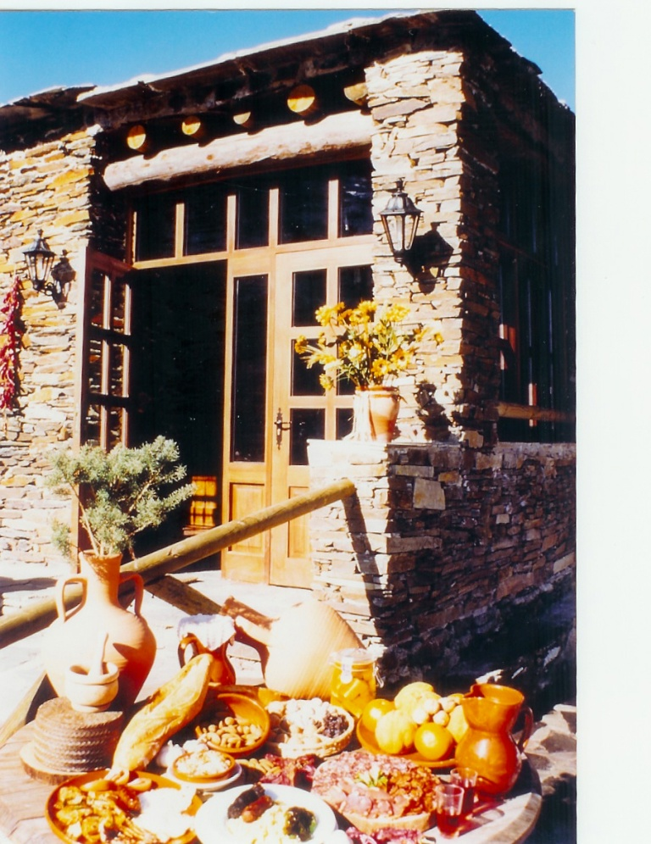
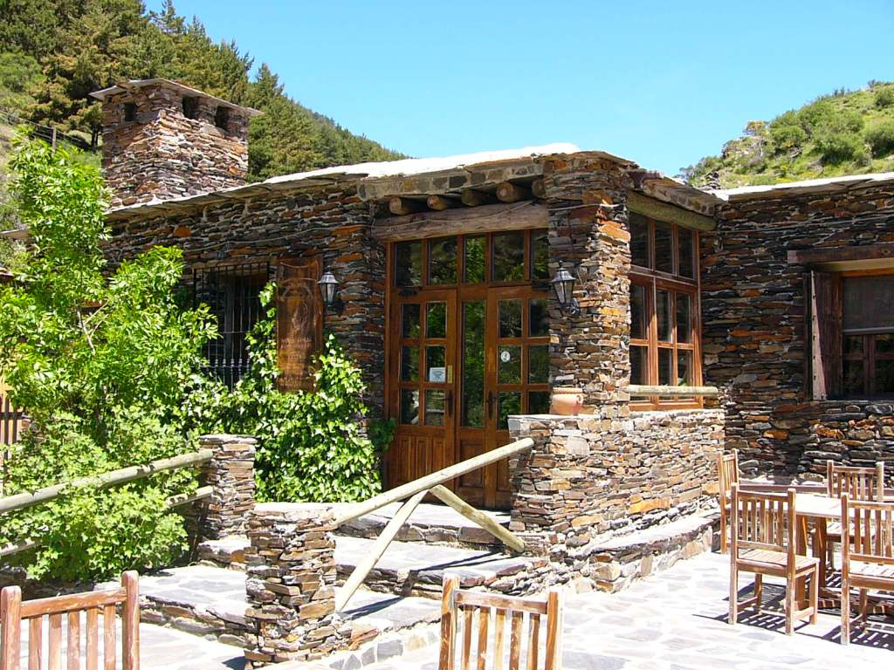
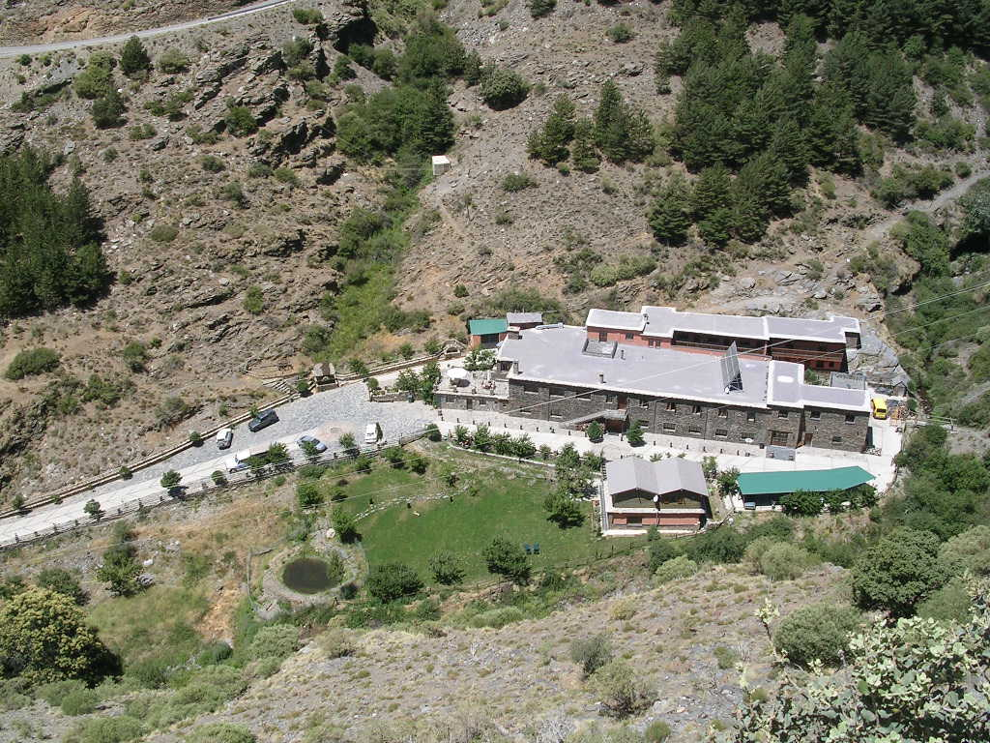
General panoramic view from the complex
Main entrance to our Restaurant

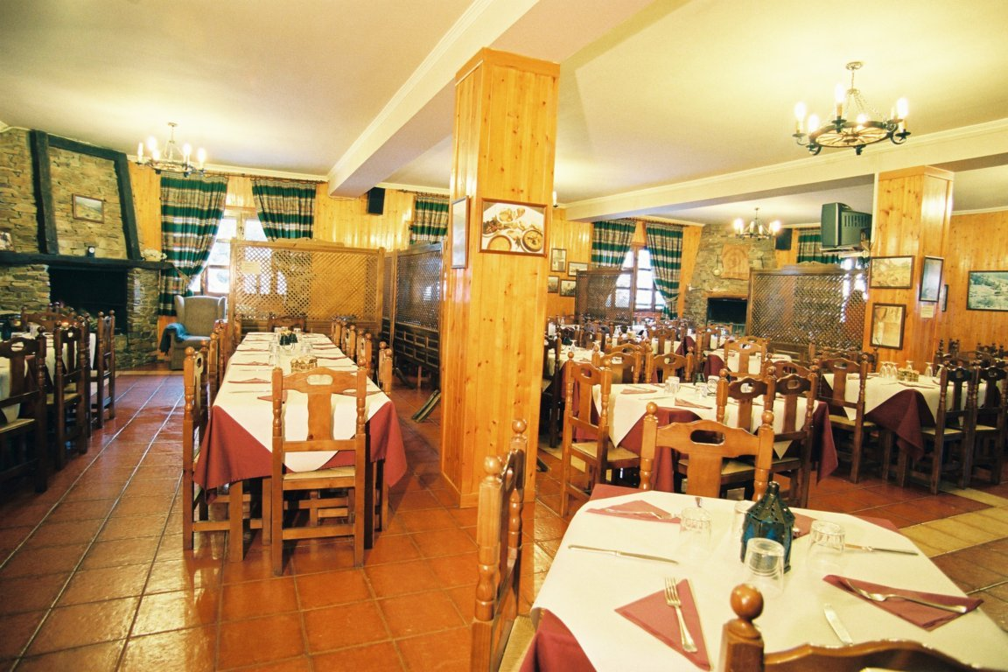
Restaurant with capacity over 150 customers

Front entrant to l Restaurant
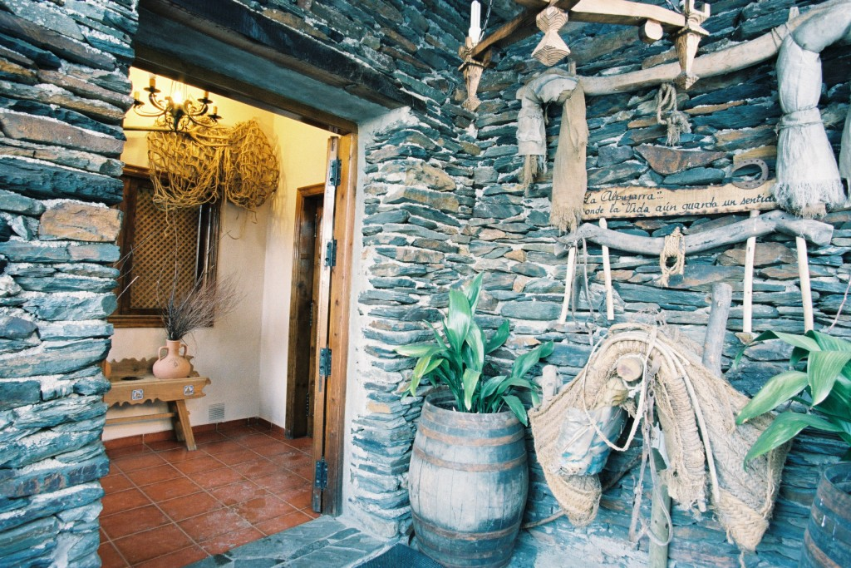

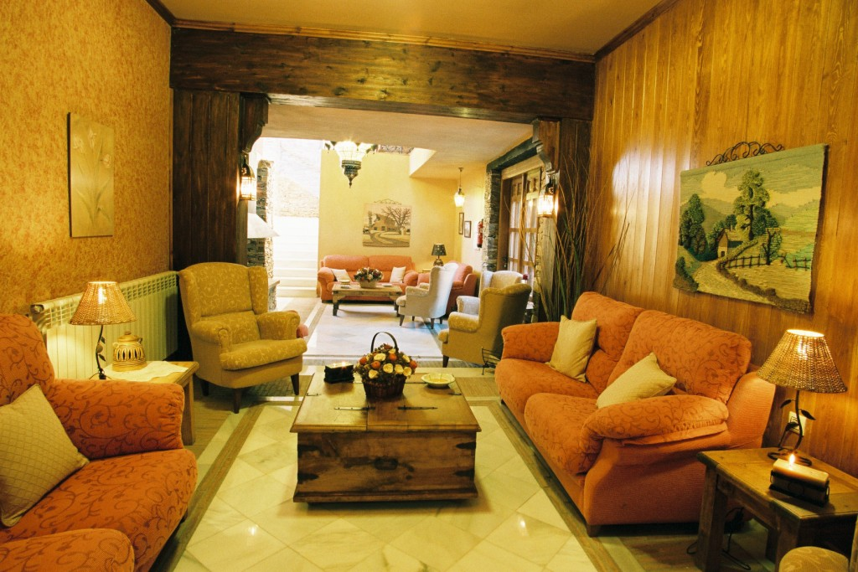
King size double room Main lounge top superior

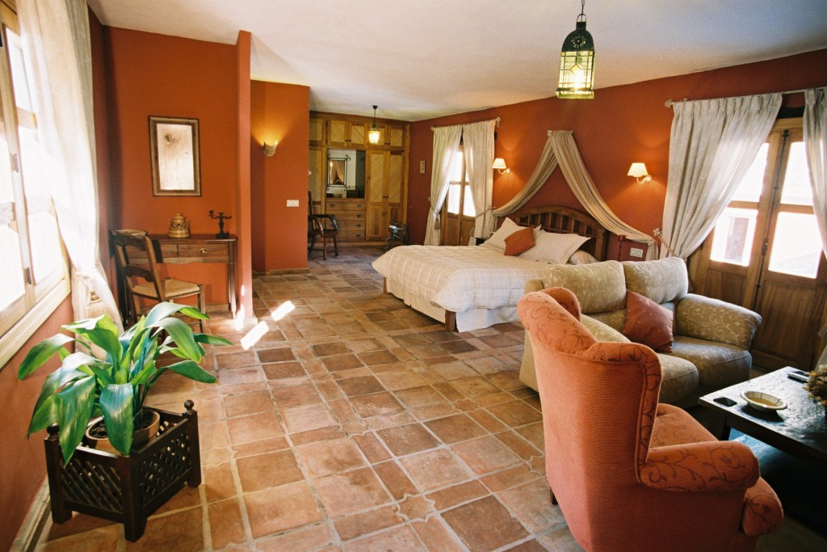

APARTMENT OF DIRECTION
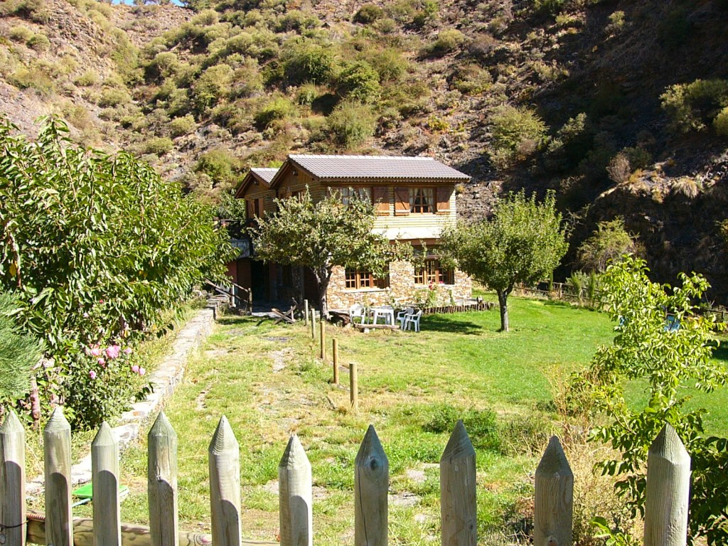
WOODEN Bungalows in garden area

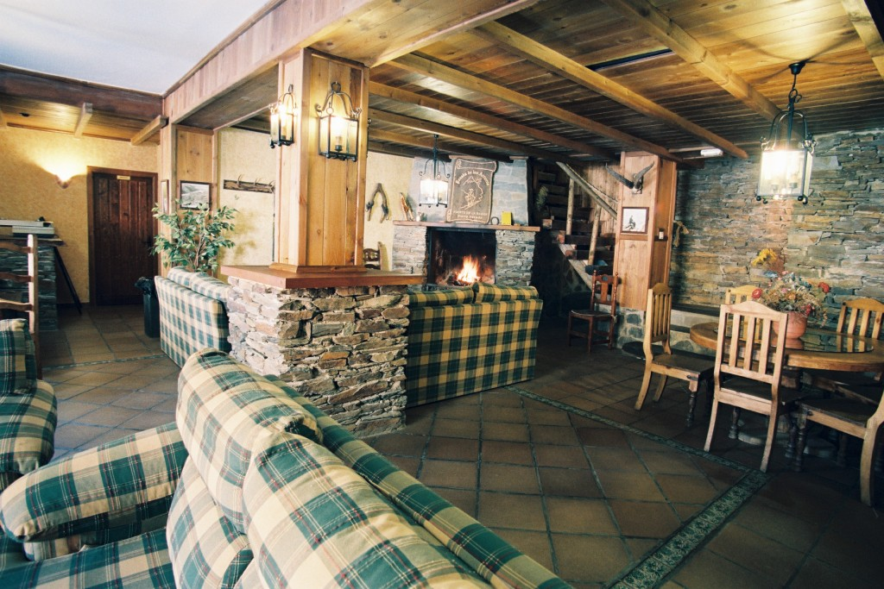

Salón – Ground floor

Winter at our stables
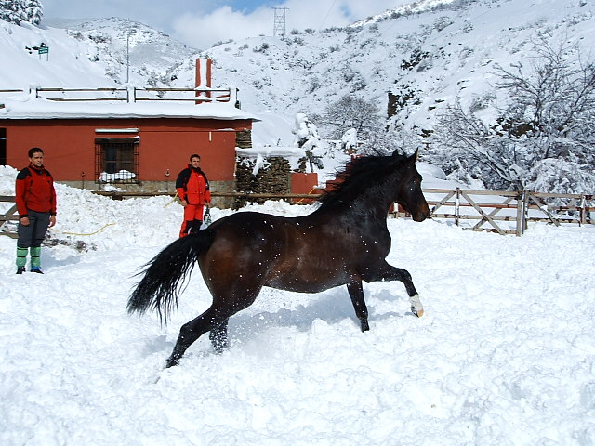
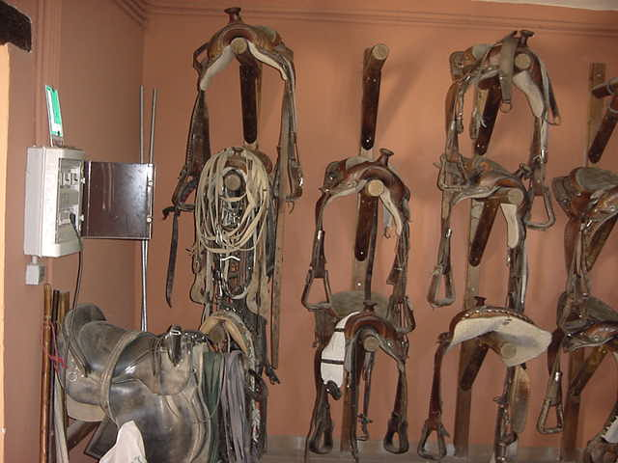

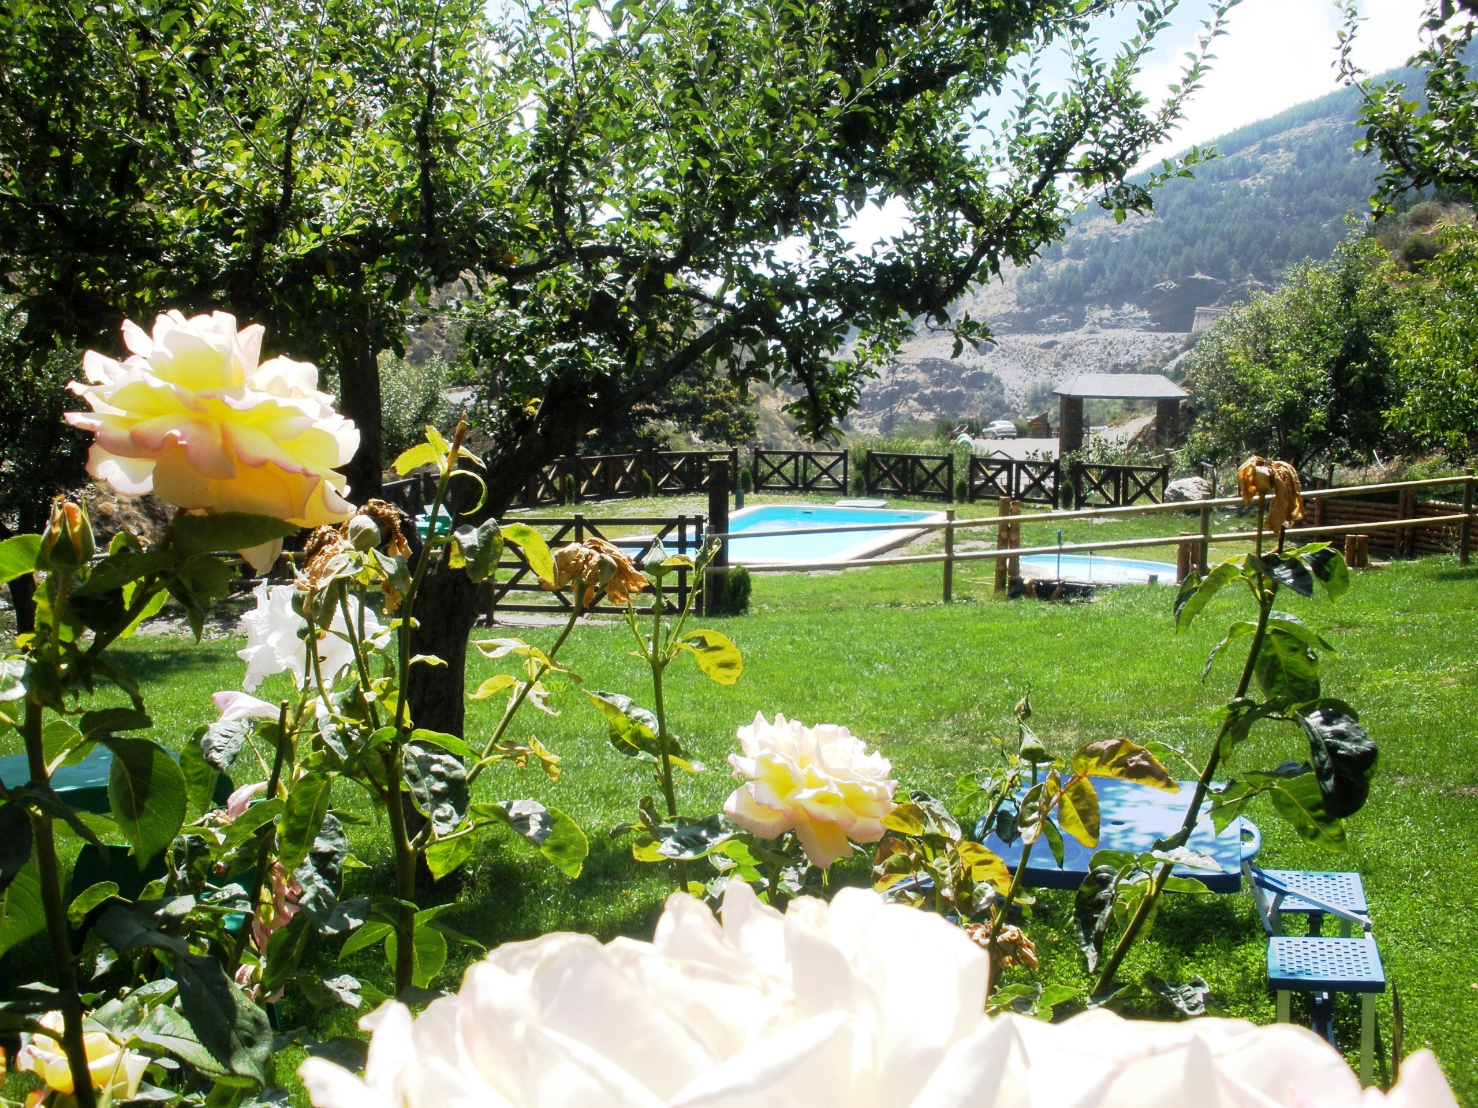

Summer—

Swimming pool and garden area

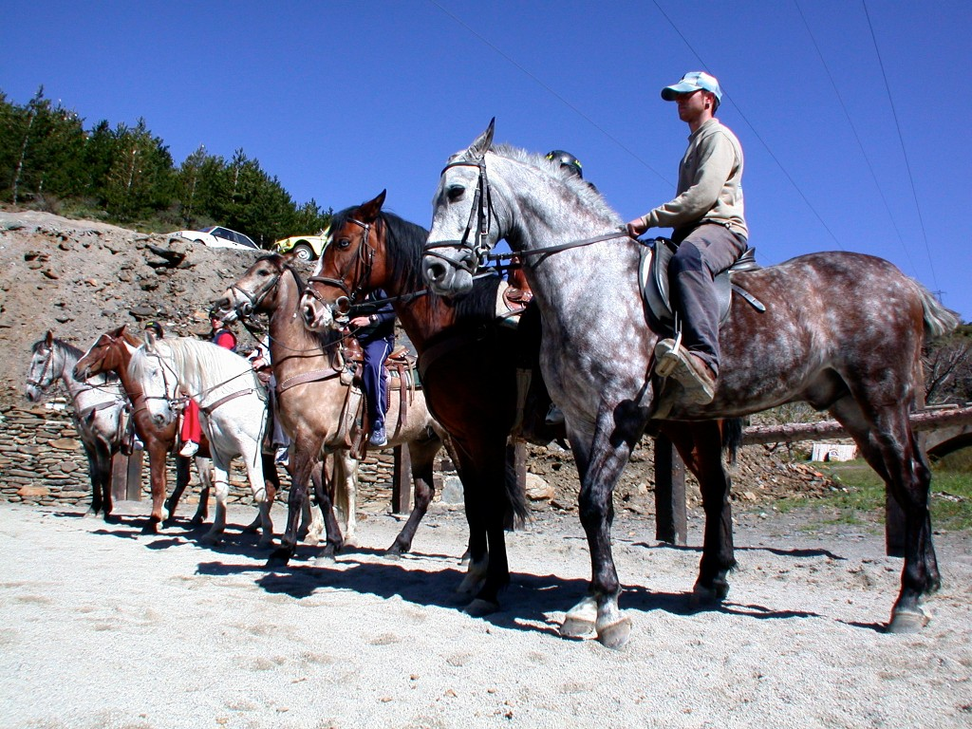
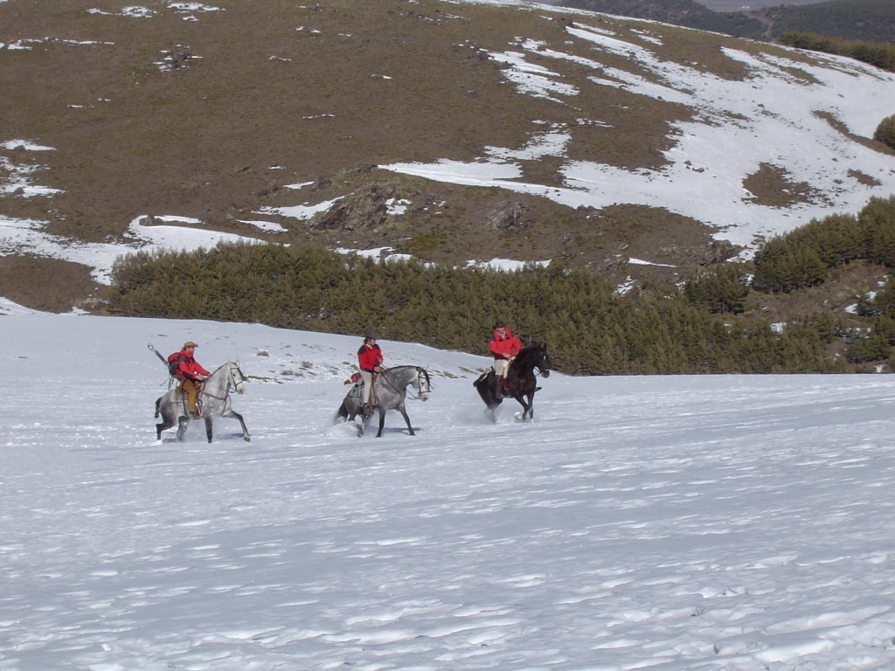

In the heart of the mysterious Alpujarra,
Moorish culture, historic legate, remembrances….
You´re welcomed to peace, charm, quietness
Enjoy our mountains, our snowy summits,
our wild river; breeze our fresh, pure and tidy air!
We belong to a past and forgotten century.l
Where Life still has kind of meaning….!!!

